**Tasks**

The visualization, titled "Unauthorized Immigrant % of Labor Force in Each State," is designed to support several comparative and informative tasks:

**Geographical Comparison:** It enables viewers to compare the percentage of unauthorized immigrants in the labor force across different states, highlighting geographical variations.

**Identify Patterns:** Viewers can identify patterns of unauthorized immigration across the United States, particularly noting the concentration in specific regions.

**Quantitative Analysis:** By providing exact percentage values for each state, the visualization supports quantitative analysis of unauthorized immigration's impact on the labor force.

**Insightful Conclusion:** The summarizing statement in the visualization helps viewers to quickly grasp the overarching trend, which indicates a more severe unauthorized immigration problem in southern states compared to northern states.

From this visualization, viewers will learn about the distribution and magnitude of unauthorized immigrants in the U.S. labor force, gaining insights into how this issue varies regionally. The design aims to foster a deeper understanding of the unauthorized immigration issue, promoting informed discussions on the topic.

**Data**

**Source:** The data for the visualization was sourced from “Pew Research Center estimates based on augmented U.S. Census Bureau data, American Community Survey 2021 (IPUMS).”

**Questions or Concerns:** I don’t know the meaning of z and the difference of column “industry with the most unauthorized immigrant workers” and column “Occupation with the most unauthorized immigrant workers”.

**Procession or Clean up:** Need to exclude the state with unknown industries. And this is reflected in my final version pictures.

**Design process**

I decided to draw a map showing Unauthorized Immigrant % of Labor Force in Each State.

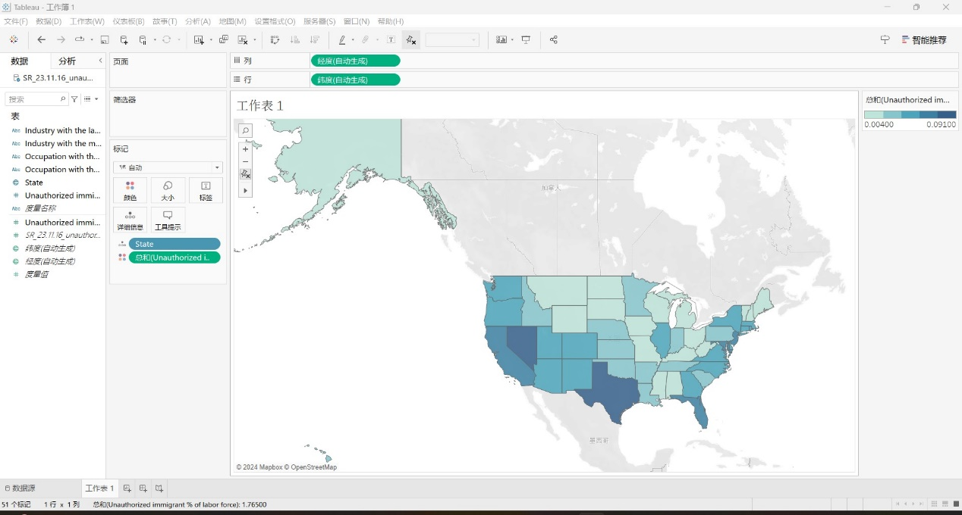

In order to emphasize the data of the states of the United States, I decided to delete all other countries in the background.

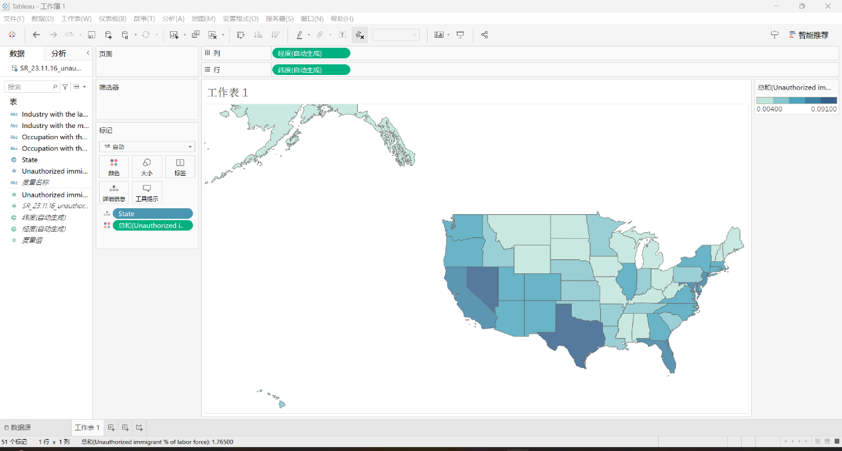

Finally, I decided to add the actual number onto each state to make it clearer. And I also change the title and add a comment on the picture.

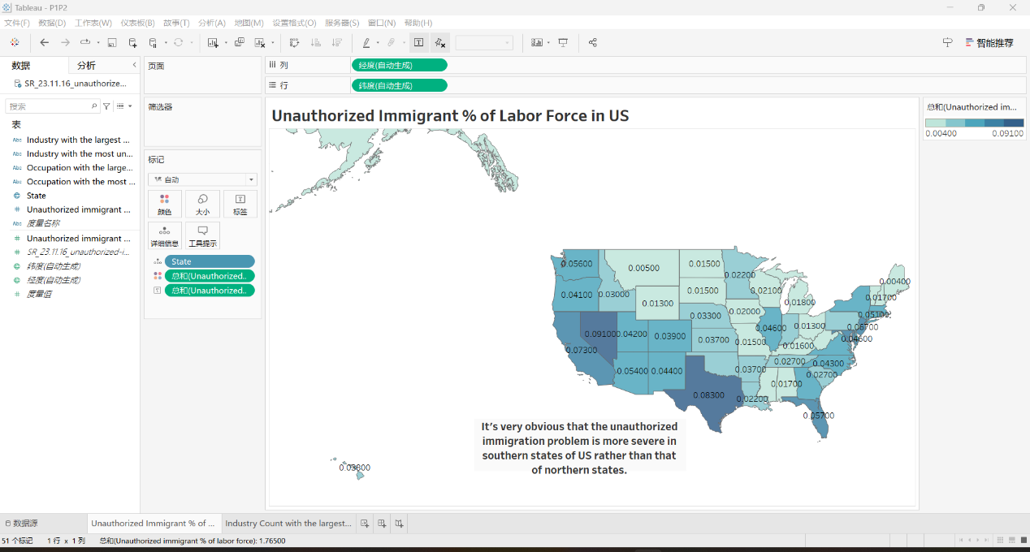

**Qualitative self-evaluation**

**Design Evaluation:** My design adheres to Tufte's principles, effectively using color gradients to show data without distortion, highlighting regional differences in unauthorized immigrant percentages.

**Effectiveness:** The visualization is clear and informative, providing immediate understanding through direct data representation and quantitative labels for each state.

**Improvement Areas:** Could enhance accessibility by considering color vision deficiencies and adding interactive elements for deeper data exploration.

**Class Principles Connection:** Reflects our class focus on clarity, accuracy, and efficiency in data presentation, recognizing the need for continuous refinement.